Inspiration
Friendstagram
[Project Plan]
Version 1.0

By: Royce Ang Jia Jie, Manav Arora, Jovan Huang Tian Chun, Clarence Hong Shi Man, Zhu Weiji, Tan Hui Zhan
Revision History

Revision Number | Date | Primary Author(s) | Comments
0.1 | Feb 21st, 2022 | Manav Arora, Jovan Huang Tian Chun, Clarence Hong Shi Man, Tan Hui Zhan | First version
0.2 | Mar 13th, 2022 | Manav Arora, Jovan Huang Tian Chun, Clarence Hong Shi Man, Tan Hui Zhan, Zhu Weiji, Royce Ang Jia Jie | Completed Project Plan
1.0 | Mar 13th, 2022 | Manav Arora | Reviewed and approved Project Plan

Table of Contents

1 Introduction 3
1.1 Project Overview 3
1.2 Project Description and Scope 3
2 Project Organization 5
2.1 Team Structure 5
2.2 Roles and Responsibilities 5
2.3 Team Communication 6
3 Process Definition 7
3.1 Lifecycle Model 7
4 Schedule 8
4.1 Activity Dependencies and Schedule 8
4.2 Work Breakdown Structure 11
4.3 Work Packages 11
4.4 Activity Dependencies 12
4.5 Work Package Details 13
5 Project Estimates 17
5.1 Code Size Estimation using Function Points 17
5.2 Effort, Duration & Team Size Estimation 20
5.3 Cost Estimates 20
6 Product Checklist 22
7 Best Practice Checklist 23
8 Risk Management 24
9 Quality Assurance 26
10 Monitoring & Control 27

1 Introduction

1.1 Project Overview

Friendstagram is a responsive web-application that acts as a friend recommendation system for Nanyang Technological University students. Given that students are usually on their mobile phones, a web-application that is suitable for mobile will be built. Based on users’ personal interests and hall accommodation information, Friendstagram will generate a list of new potential friends for users to reach out to.

1.2 Project Description and Scope
Friendstagram is an idea that arose during a discussion among Nanyang Technological University students whose daily lives have been disrupted by COVID-19 pandemic. Due to COVID-19 pandemic, many social restrictions have been put in place to prevent the spread of the virus amongst student cohorts. The inability to interact with others face-to-face has caused students to achieve a less fulfilling university life. Hence, Team Inspiration decided to create Friendstagram, a web application to help students cope with this situation. Team Inspiration will be in charge of both the front-end and back-end development of this web application.
The basis of Friendstagram is a friend recommendation system in the form of a responsive web application that takes a number of possible constraints into account. These can be such limits as:
- The user intends to find new potential friends who stay in the same hall;
- The user intends to find new potential friends who likes playing badminton;
- The user intends to find new potential friends who loves to study;
- It is important that users can choose multiple interests;
- The users might have greater preference for one interest over another;
- The user must be able to change their interests from time to time.
The above are just some possible examples of the constraints. There will be more discussion on the final possible constraints in a later document.
Given these preferences, Friendstagram will allow users to key in their personal interests and hall accommodation information before generating a list of potential friends. However, as this project involves only Nanyang Technological University students and is a Minimum Viable Product (MVP), functionalities such as real-time texting are beyond the scope. These functionalities can be considered after the User Acceptance Testing of the MVP is completed where we have users’ feedback. Team Inspiration will be providing the deliverables as stated in this document which includes all the source code, lo-fi prototype, use case model, a test data set and database schema.
Friendstagram is responsible for generating a list of potential friends for users after they have logged in and keyed in their personal interests and hall accommodation information. Friendstagram’s responsibilities are complete once the list of potential friends and their personal information like interests and hall accommodation are generated for the users. This allows the users to reach out to these new potential friends.
The system of Friendstagram will include all the necessary user interfaces to quickly and intuitively determine the user’s requirements and preferences.
Also, since Friendstagram is only targeted at Nanyang Technological University students, users will have to use their school email to sign up for an account on our platform.

2 Project Organization

2.1 Team Structure
The following is the list of executive roles:
- Project Manager: Manav Arora
- QA Manager: Jovan Huang Tian Chun
- QA Engineer - Tan Hui Zhan
- Lead Developer: Royce Ang Jia Jie
- Front-end Developer - Royce Ang Jia Jie
- Back-end Developer - Zhu Weiji
- Release Engineer/Manager - Clarence Hong Shi Man

2.2 Roles and Responsibilities
Project Manager: Manav Arora
- Oversees project progress
- Approves and executes project plan
- Assigns tasks and reports status of project to team members
- Manages and motivates team members
- Represents the team to the outside world
- Ensures overall delivery of product is completed smoothly
QA Manager: Jovan Huang Tian Chun
- Ensure that overall product and process quality are of high standards
- Implement QA processes
QA Engineer: Tan Hui Zhan
- Devise test plans
- Conduct comprehensive tests
Lead Developer: Royce Ang Jia Jie
- Overall technical lead
- Responsible for technical aspects of product release
- Ensure that the final system design is of high standards
Front-end Developer: Royce Ang Jia Jie
- Conduct front-end programming for web application
- Participates in the entire SDLC
- Generates work products including documentation, source code, unit and integration tests
Back-end Developer: Zhu Weiji
- Server, application and database programming
- Participate in the entire SDLC
- Generates work products including documentation, source code, unit and integration tests
Release Engineer/Manager: Clarence Hong Shi Man
- Create baselines and build and integrate changes for delivery
- Manage releases of the product prototype

2.3 Team Communication
Team Inspiration communication channels include the following:
- Weekly meetings are held on the online Zoom platform or in person when necessary, either on Monday or Wednesday.
- Important information and updates are announced via Discord and Whatsapp.
- Zoom, Discord and Whatsapp messaging are used to facilitate discussions and clarify doubts.
- Subgroups are formed in order to facilitate stronger focus and cooperation in completing the subtasks.
- Github is used to share codes and facilitate clear communication on the status of every issue.
- Google Drive is used to help facilitate real-time files sharing and documentation editing, allowing real-time communication of ideas and collaboration between multiple team members.
- Backlogs are used to communicate outstanding tasks and task’s status.

3 Process Definition

3.1 Lifecycle Model
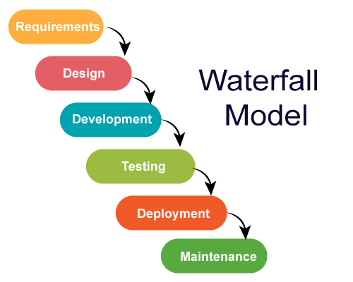
Fig 1. Waterfall SDLC Model Illustration
Team Inspiration intends to use the Waterfall Software Development Life Cycle (SDLC) Model from the gathering of requirements to the maintenance of the project, Friendstagram. In this technique, the development cycle is broken down into different phases wherein each phase is connected to the next sequentially, i.e. output of one serves as input to another.
This methodology has allowed us to speedily develop a product that is ready for release in a short amount of time. This method allows us to adhere to deadlines and keep the project on track. It helps us set out clear and concise requirements from an early stage which facilitate the development process. Overall, this method allowed us to better manage our time and consolidate a streamlined effort to complete this project.

4 Schedule

4.1 Activity Dependencies and Schedule

Milestone Description | Category | Progress | Start Date | End Date
Project Planning(Proposal) |  |  | 24/1/22 | 6/2/22
Assignment of Team Roles | On Track | 100% | 24/1/22 | 25/1/22
Identify Problem | On Track | 100% | 25/1/22 | 26/1/22
Elicit Requirements | On Track | 100% | 26/1/22 | 29/1/22
Identify Technologies to be used | On Track | 100% | 26/1/22 | 27/1/22
Use Case Modeling | On Track | 100% | 27/1/22 | 30/1/22
Design System Architecture | On Track | 100% | 30/1/22 | 5/2/22
Design User Interface | On Track | 100% | 27/1/22 | 6/2/22
Backend Development |  |  | 7/2/22 | 28/2/22
Design Database Structure and Schema | On Track | 100% | 7/2/22 | 9/2/22
Deploy Server to Cloud | On Track | 100% | 9/2/22 | 10/2/22
Develop API Endpoints |  |  | 12/2/22 | 28/2/22
Authentication Endpoints | On Track | 100% | 12/2/22 | 17/2/22
Friends Management Endpoints | On Track | 100% | 17/2/22 | 23/2/22
Groups Management Endpoints | On Track | 100% | 23/2/22 | 28/2/22
Frontend Development |  |  | 7/2/22 | 28/2/22
Authentication Pages | On Track | 100% | 7/2/22 | 13/2/22
Friends Management Pages | On Track | 100% | 15/2/22 | 21/2/22
Groups Management Pages | On Track | 100% | 21/2/22 | 27/2/22
System Integration |  |  | 27/2/22 | 17/3/22
Integration of Authentication Pages | On Track | 100% | 27/2/22 | 5/3/22
Integration of Friends Mgmt Pages | On Track | 100% | 5/3/22 | 11/3/22
Integration of Groups Mgmt Pages | On Track | 100% | 1/3/22 | 16/3/22
Quality Planning and Control |  |  | 6/2/22 | 9/3/22
Implement testing for Authentication | On Track | 100% | 17/2/22 | 20/2/22
Implement testing for Friends Mgmt | On Track | 100% | 23/2/22 | 26/2/22
Implement testing for Groups Mgmt | On Track | 100% | 28/2/22 | 3/3/22
Implement Integration Testing | On Track | 100% | 5/3/22 | 8/3/22
Other Documentation |  |  | 7/2/22 | 28/3/22
System Requirement Specification | On Track | 100% | 7/2/22 | 20/2/22
Project plan | On Track | 100% | 7/2/22 | 20/2/22
Quality plan | On Track | 100% | 21/2/22 | 6/3/22
Risk management plan | On Track | 100% | 21/2/22 | 6/3/22
Design for software maintainability report | On Track | 100% | 7/3/22 | 20/3/22
Configuration Management Plan | On Track | 100% | 7/3/22 | 20/3/22
Change Management Plan | On Track | 100% | 7/3/22 | 20/3/22
Release Plan | On Track | 100% | 7/3/22 | 20/3/22
Test Plan | On Track | 100% | 21/3/22 | 27/3/22
Test Cases | On Track | 100% | 21/3/22 | 27/3/22
Requirements Test Coverage | On Track | 100% | 21/3/22 | 27/3/22

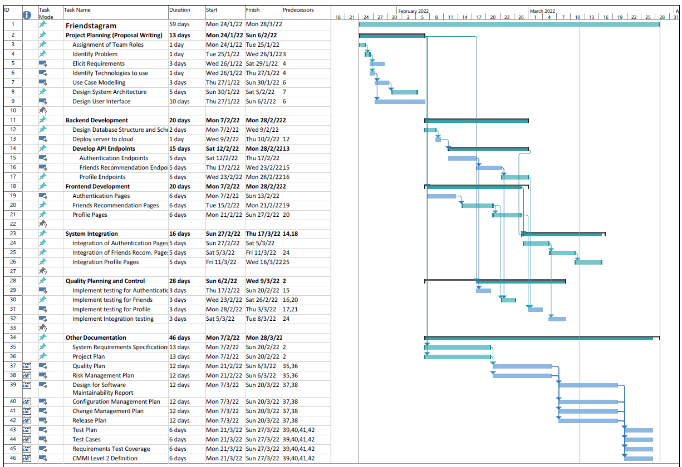
Fig 2. Gantt Chart of Friendstagram Project

4.2 Work Breakdown Structure
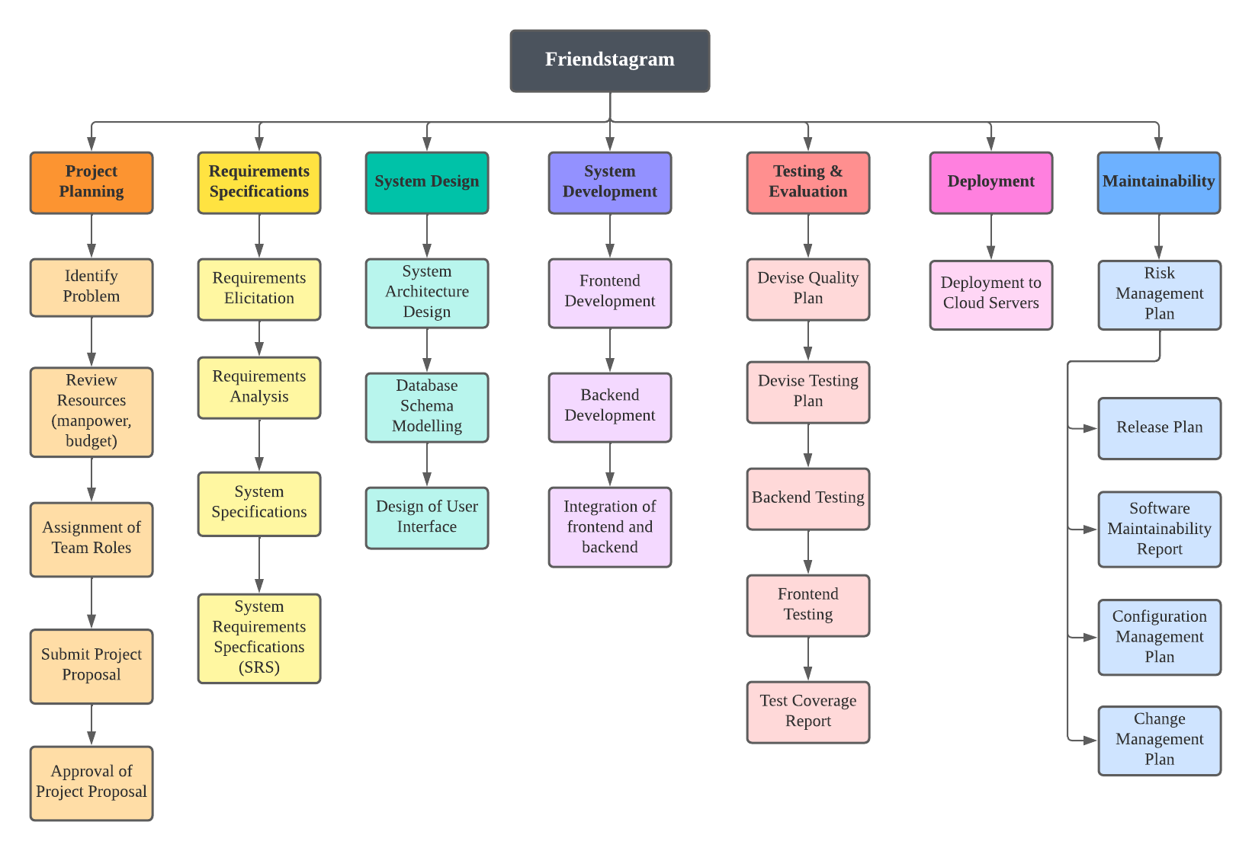
Fig 3. Work Breakdown Structure of Friendstagram

4.3 Work Packages
The work for the project, Friendstagram will be broken into different phases and milestones of the software development life cycle. They are as follows:
- Project Planning
- Requirement Specification
- System Design
- Documentation
- Front-end development
- Back-end development
- System Testing
- System Integration
- Project Handover (submission) to Client

4.4 Activity Dependencies

Activity Network Diagram + Work Package & Activity Table
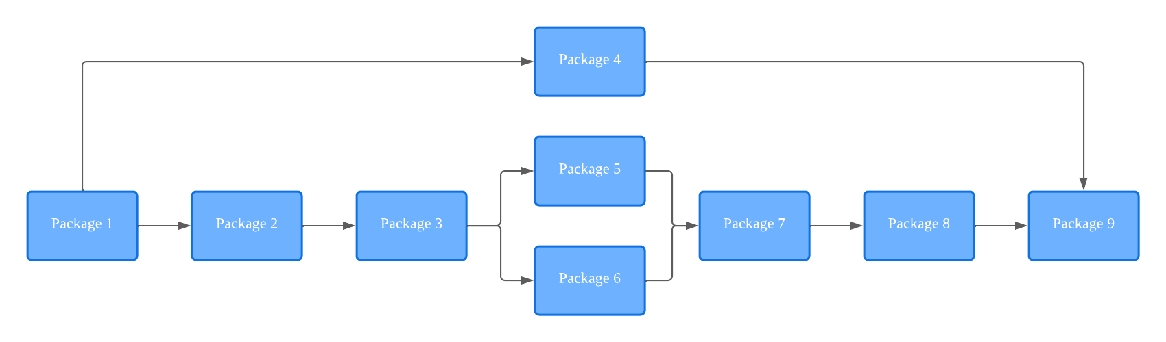
No. | Description | Start Date | Duration | End Date | Dependencies | Comments
1 | Project Planning | 24/1/22 | 13 days | 6/2/22 | -
2 | Requirement Specifications | 7/2/22 | 13 days | 20/2/22 | 1
3 | System Design | 27/1/22 | 11 days | 6/2/22 | 2
4 | Documentation | 6/2/22 | 76 days | 11/4/22 | 1 | Occurs concurrently with others
5 | Frontend Development | 7/2/22 | 20days | 28/2/22 | 3 | Occurs concurrently with 6
6 | Backend Development | 7/2/22 | 20days | 28/2/22 | 3 | Occurs concurrently with 5
7 | System Testing | 06/2/22 | 31 days | 09/3/22 | 5, 6
8 | System Integration | 27/2/22 | 18 days | 17/3/22 | 7
9 | Project Handover (submission) to Client | 27/3/22 | 1 day | 27/3/22 | 4,8

4.5 Work Package Details

Project | Friendstagram
Work Package | 1 – Project Planning (1 of 9)
Assigned To | All
Effort | 13 Days
Start Date | 24/01/22
End Date | 06/02/22
Purpose | Choose a project topic, and determine overall direction of the project which will be consistently updated in future work packages.
Input(s) | -
Activities | This work package involves distributing team roles and identifying the problem and technologies to be used.
Output(s) | A written document of the Project Proposal and Use Case Model

Project | Friendstagram
Work Package | 2 - Requirement Specification
Assigned To | All
Effort | 13 Days
Start Date | 07/02/22
End Date | 20/02/22
Purpose | List down the features needed and distribute work
Input(s) | Package 01
Activities | This work package involves doing feasibility study, requirements elicitation, constraints evaluation and project schedule planning. It also involves providing the operational requirements, functional requirements, input requirements, process requirements, output requirements, hardware requirements, software requirements and deployment requirements.
Output(s) | A written document of System Requirement Specification

Project | Friendstagram
Work Package | 3 – System Design
Assigned To | All
Effort | 11 days
Start Date | 27/01/22
End Date | 06/02/22
Purpose | To design a backend architecture to support front-end development and discuss on overall system design
Input(s) | Package 02
Activities | Planning structure and schema of database, setting up the server
Output(s) | Database schema, high-level design and architectural specification

Project | Friendstagram
Work Package | 4 - Documentation
Assigned To | All
Effort | 76 Days
Start Date | 06/02/22
End Date | 11/04/22
Purpose | Document everything, from Project Proposal to UI/UX Design to Unit Test
Input(s) | Package 01
Activities | Writing documentation for every stage of developing software.
Output(s) | Project Proposal, Use Case Description, Quality Plan, System Requirement Specification, Project Plan, Risk Management Plan, Test Plan, Test Cases & Requirement Test Coverage Report. Front-end mockup and wireframing, Recommendation algorithm, Back-end Design

Project | Friendstagram
Work Package | 5 - Frontend Development
Assigned To | Royce, Hui Zhan
Effort | 20 Days
Start Date | 07/02/22
End Date | 28/02/22
Purpose | Design the user interface between the system and the users, to make it easy to use, and implement the front-end of the application.
Input(s) | Package 03
Activities | Front-end mockup and wireframing, Discuss flowchart for questionnaire, Implement login and signup pages, main application pages, and mobile responsiveness. Implement modules according to the design specifications noted in the specification document
Output(s) | Front-end mockup and wireframing, Source code and logical files, Working front-end design ready for integration

Project | Friendstagram
Work Package | 6 - Backend development
Assigned To | Weiji
Effort | 20 Days
Start Date | 07/02/22
End Date | 28/02/22
Purpose | Implement back-end structure
Input(s) | Package 03
Activities | Analyze data flow relationships, entity relationships, implement database and API calls
Output(s) | Working back-end server ready for integration

Project | Friendstagram
Work Package | 7 - System Testing
Assigned To | All
Effort | 31 Days
Start Date | 06/2/22
End Date | 09/3/22
Purpose | Implement unit testing
Input(s) | Package 07
Activities | Simulate how a user might interact with the system. Testers will look out for system performance and integrity and ensure the program meets requirement specifications.
Output(s) | Test report

Project | Friendstagram
Work Package | 8 - System Integration
Assigned To | Royce, Hui Zhan, Weiji
Effort | 18 Days
Start Date | 27/2/22
End Date | 17/3/22
Purpose | Integrate the front-end and back-end
Input(s) | Package 05, 06
Activities | Integration of login page and registration page, profile page and recommendation page.
Output(s) | Working Web-Application prototype

Project | Friendstagram
Work Package | 9 - Project Handover
Assigned To | All
Effort | 1 Day
Start Date | 27/03/22
End Date | 27/03/22
Purpose | Finish all documentations and handover to client
Input(s) | All packages
Activities | Handover all documentations and codes to client  Post-project Review - reflect on what was done well and mistakes made (how to avoid them in future projects)
Output(s) | All

5 Project Estimates

5.1 Code Size Estimation using Function Points
Unadjusted Function Points
Friendstagram have the following functionalities:
Users:
- Register
- Login
- Logout
- Find Friends
- View recommend friend profile
- View personal profile
- Edit personal profile
Unadjusted function points are measured based on 5 primary component elements of the following functions: Inputs, Outputs, Inquires, Logical Files, and Interfaces. Each element ranges from Low Complexity, Medium Complexity to High Complexity. The detailed evaluation of the complexity is as follows:
Rating Inputs:
- Register for an account (Email, Password)
- Gathering user’s information after registration (Hall Accomodation, Interests, Interests Ratings, About Me)
Rating Outputs:
- Displaying a list of recommended friends that matches user’s profile (Images, Interests)
- Displaying the profile of a recommended friend (Contains Email, About Me, Hall Accommodation Details, Interests)
- Displaying user’s personal profile information (Email, Hall Accommodation Details, Interests)
- Displaying history of matched friends

Rating Inquires:
- Selecting user account when user is logging in
- Selecting a list of recommended friends that matches user’s profile
- Selecting a recommended friend profile

Rating Logical Files:
- User Account (Email, Password, Hall Accommodation Details, Interests, About Me)
- User Personal Information (Email, Hall Accommodation Details, Interests, About Me)

Rating Interfaces:
- One External Generator used (Images)
Summary of the above analysis:
Element | Complexity | Detail
Inputs | Low | Register for an account
Inputs | Low | Gathering user’s information after registration
Outputs | High | Displaying a list of recommended friends
Outputs | Low | Displaying the profile of a recommended friend
Outputs | Low | Displaying user’s personal profile information
Outputs | Low | Displaying history of matched friends
Inquiries | Low | Selecting user account when user is logging in
Inquiries | High | Selecting a list of recommended friends that matches user’s profile
Inquiries | Low | Selecting a recommended friend profile
Logical Files | Low | User Account
Logical Files | High | User Personal Information
Interfaces | Low | External Image Generator API

Calculation of Unadjusted Function Points:
Characteristic | Low Complexity | Medium Complexity | High Complexity
# Inputs | 2 x 3 = 6 | 0 x 4 = 0 | 0 x 6 = 0
# Outputs | 3 x 4 = 12 | 0 x 5 = 0 | 1 x 7 = 7
Inquiries | 2 x 3 = 6 | 0 x 4 = 0 | 1 x 6 = 6
Logical Files | 1 x 7 = 7 | 0 x 10 = 0 | 1 x 15 = 15
Interfaces | 1 x 5 = 5 | 0 x 7 = 0 | 0 x 10 = 0
Unadjusted FP | 36 | 0 | 28
Total = L + M + H | 64

Adjusted Function Points
Influence Factors | Score (0-5) | Detail
Data communications | 5 | The web application has both front-end and back-end and it supports 24/7 communication with Django Server, which allows it to function properly.
Distributed functions | 4 | Distributed processing and data transfer are unidirectional between the front-end side and the backend servers.
Performance | 3 | Response time / throughput is important and critical to the part of the application where recommendations of potential friends are generated. There is no need to have a special design for CPU utilization.
Heavily used | 1 | Users will use the application only when they want to find new friends. Although the load on the system is likely to be light, we took timing into consideration where the application needs to generate the list of recommended friends in 1-3 seconds.
Transaction rate | 2 | Throughout the day, transactions are anticipated to be relatively constant.
On-line data entry | 4 | On-line data entry is extremely important for the web application. We need users to input their personal information which will be used to generate a list of new recommended friends.
End-user efficiency | 4 | We have a few efficient designs to make the web application intuitive and easy for end users to use and navigate.
On-line update | 2 | We support online updates of major internal logical files although it is not very frequent. It only occurs when new users sign up for an account or update their personal information.
Complex processing | 5 | Friendstagram’s recommendation system has a complex algorithm behind it.
Reusability | 2 | Our application is currently a Minimal Viable Product (MVP), and is at a much smaller scale. Therefore, there is less emphasis on reusability.
Installation ease | 0 | Our prototype is a web-app, and hence need not be installed.
Operational ease | 3 | The web application is designed for unattended operation. Unattended operation means no human intervention is required to operate the system other than to start up or shut down the application.
Multiple sites | 1 | Our web application only has one site.
Facilitate change | 3 | Our web application supports changes when users update their personal information. This will update the internal logical files and will not change any of the functionalities or the algorithm behind our friend recommendation system.
Total | 39

Scoring (0 – 5)
0 = No influence
1 = Insignificant influence
2 = Moderate influence
3 = Average influence
4 = Significant influence
5 = Strong influence
Influence multiplier = 39 x 0.01 + 0.65 = 1.04
Adjusted Function Point Total: 64 x 1.04 = 66.56
Lines of Code
For the frontend codes, we used HTML and JavaScript / ES6.
The average number of source lines per FP for HTML and Javascript / ES6 is 34 and 47 respectively.
For the backend codes, we used Python and SQL.
The average number of source lines per FP for Python and SQL is 24 and 21 respectively.
Overall, the average number of source lines per FP for our project is 31.5.
Therefore, we have: Lines of Code = 66.56 FP X 31.5 LOC/FP = 2097 LOC.

5.2 Effort, Duration & Team Size Estimation
In order to estimate the effort and duration needed to complete this project, we use function points to calculate Effort, Duration and Team size and finally the schedule. We make sure that these estimates are expanded to account for project management and extra contingency time to obtain the total average effort estimates.
Based on our team’s history projects, we have an average of 200 LOC/PM.
Hence, the estimated effort, duration and team size is as follows:
Effort = (2097 LOC) / (200 LOC/PM) = 10.49 PM
Duration = 3.0 x 10.49^(0.33) = 2.17 months
Team Size = 5.99 PM / 2.17 months = 2.76 people

5.3 Cost Estimates

Hardware:
Developer workstations:
Macbook Pro
8-Core CPU
14-Core GPU
16GB Unified Memory
Apple M1 Pro Chip
512 GB SSD Drive
Total
$3000.00

Software:
Development Tools:
PythonAnywhere Web Server | $0.00
React library | $0.00
Django library | $0.00
Python | $0.00
JavaScript | $0.00
GitHub | $0.00
Netlify | $0.00
PythonAnywhere | $0.00

Documentation Tools:
Visual Paradigm | $0.00
Microsoft Visual Studio Code | $0.00
Microsoft Office | $0.00

6 Product Checklist
Items listed below will be delivered on the stated deadlines.

No. | Project Deliverable | Estimated Deadline
1 | Project proposal, Use case model | February 7, 2022
2 | System Requirement Specification (SRS) | February 21, 2022
3 | Quality Plan | February 21, 2022
4 | Project Plan | March 14, 2022
5 | Risk Management | March 14, 2022
6 | Design Report on software maintainability | March 28, 2022
7 | Configuration Management Plan | March 28, 2022
8 | Change Management Plan | March 28, 2022
9 | Release Plan | March 28, 2022
10 | Test Plan | April 11, 2022
11 | Test Cases and Requirements Test Coverage report | April 11, 2022
12 | CMMI level 2 definition | April 11, 2022

7 Best Practice Checklist
No. | Practices | ✔
1 | Documentation must be in a standardized format.
2 | Weekly meetings should be held in accordance with the Waterfall SDLC Model.  Each member should be made aware of any changes.
3 | Changes in code must be checked by a fellow developer and must pass the specific test case, before it can be merged.
4 | Bugs and errors should be highlighted to all team members.
5 | Coding Style must be consistent and follow the preset guidelines.
6 | Project Scheduling should be done thoroughly and followed so that the project can be completed in a timely manner while meeting requirements.
7 | Software testing should be high priority and very thorough to ensure product quality and standards.

8 Risk Management
The following risks have been identified for the Friendstagram project:
Team member unavailable before project completion
Probability: Low
Impact: High
Impacts: There will be a lack of manpower required to complete the project on time. Remaining team members will have increased workload to meet the project deadline, leading to increased stress levels and potentially conflicts.
Risk Reduction: Team members are given benefits for their hard work.
Requirements miscommunication
Probability: Medium
Impact: High
Impacts: This can lead to increased workload due to the development of features that are not required or missing out required features of the software. This will result in missing the deadline for the project due to the increased workload.
Risk Reduction: Have meetings at least once a week to reduce the probability of miscommunication. Team members must inform the team of any new updates and development knowledge.
Internal conflict between teammates
Probability: Low
Impact: Medium
Impacts: Work productivity will drop as teammates are unwilling or avoid communicating with one another. Internal conflicts will lead to friction that reduces the overall productivity of the team.
Risk Reduction: Always communicate any issues with one another before it leads to a conflict. All conflicts must be resolved as soon as possible.
Deadline delayed due to other assignments
Probability: Medium
Impact: High
Impacts: Assignments and tests will reduce the amount of time each team member can spend on the development of Friendstagram. If the reduced time is not taken into account during the project scheduling, deadlines will be delayed as there will not be enough time to finish the project on time.
Risk Reduction: Each member must inform the team of their assignment and test once they have the information. Adjust the project schedule based on the availability of each member and do more work on less busy weeks.

Lack of physical team meetings
Probability: High
Impact: Low
Impacts: Unable to discuss project progress physically, leading to lack of awareness on each team member’s progress on their assigned workload.
Risk Reduction: Have team meetings on online platforms such as discord and zoom. Ensure constant communication and updates through messaging platforms such as WhatsApp and Telegram.

9 Quality Assurance
To maintain a certain high quality standard for our project, the following quality assurance scheme has been devised. The following check will be conducted:
- Unit Testing
Every component will be tested to make sure that they are performing as expected.
- System Testing
The functionality will be checked to make sure that the application performs as intended.
- In-Place Testing
The application will be tested as a whole.
- Acceptance Testing
This will be done to ensure the application meets the requirements specification.
The specific procedures and details of the above testing methodologies will be elaborated on in the Test Plan.

10 Monitoring & Control
A multitude of features and processes are put in place to be able to successfully monitor the progress of this software project. Some of the essential ones are mentioned below:

Measurement of resource consumption:
This project involves a plethora of human resources in order to achieve the goal set out by the team. This involves efforts put into the code in terms of frontend, backend, algorithm, etc. Keeping keen notice of the resources used for each milestone allows for a smoother and successful implementation.

Identification of major project risks:
Any potential risks to the project must be identified in advance in order to come up with mitigation strategies. Detailed information on this topic is provided in the Risk Management section of this document.

Regular reviews of project progress:
The project team meets every week in order to discuss and review the status of the project while covering topics regarding code development, code testing, documentation overview, backlog etc. Physical meetings are conducted at the lab which allows for a face to face discussion on the issues mentioned above.

Timeline Planning and task decomposition:
This document outlines the estimated timeline for this project. A rough timeline can be estimated whilst breaking down the various tasks into sub-tasks, allowing for periodical reviews of the project progress. Project subcomponents and timeline estimates are included in the Schedule section of this document.

